CPE301 – fall 2019

Design Assignment 2A

Student Name: Henry Mesa

Student #: 1008099273

Student Email: mesah1@unlv.nevada.edu

Primary Github address: https://github.com/mesah1

Directory: https://github.com/mesah1/submissions

1. **COMPONENTS LIST AND CONNECTION BLOCK DIAGRAM w/ PINS**

List of Components used

Block diagram with pins used in the Atmega328PB

Part 1.

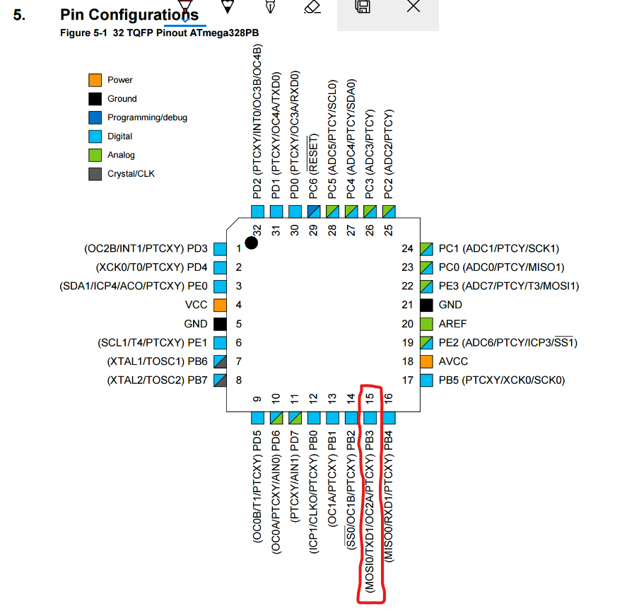

Part 2.

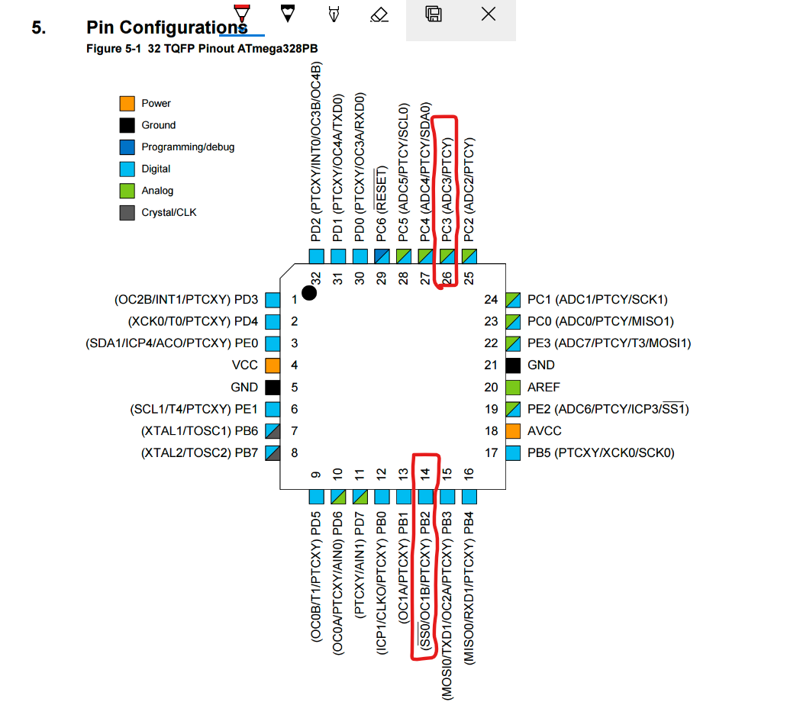

1. **INITIAL/MODIFIED/DEVELOPED CODE OF TASK 1/A**

;

; DA2A.asm

;

; Created: 9/29/2019 3:41:36 PM

; Author : Henry M

;

/* This program is designed to turn "ON" and "OFF" a signal

out of PortB.3 with a 40% duty cycle and a period of 625ms

forever */

.include "m328pbdef.inc"

SBI DDRB, 3 ;SET BIT 3 IN PORTB TO OUTPUT

L1:

SBI PORTB, 3 ;SEND TO PORTB VALUE OF 1 = ON

CALL delay250ms ;DELAY OF 250ms

CBI PORTB, 3 ;SEND TO PORTB VALUE OF 0 = 0FF

CALL delay375ms ;DELAY OF 375ms

JMP L1

;--------------------------------------------------------------------------

delay250ms:

ldi R19, 11

d0: ldi R20, 255

d1: ldi R21, 237

d2: dec R21

brne d2 //if R21 != 0 go to d2 label

dec R20

brne d1 //if R20 != 0 go to d1 label

dec R19

brne d0 //if R19 != 0 go to d0

ret

;----------------------------------------------------------------------------

delay375ms:

ldi R19, 12

s0:

ldi R20, 254

s1:

ldi R21, 245

s2:

ldi r22, 255

dec r21

brne s2 //if R21 != 0 go to s2 label

dec R20

brne s1 //if R20 != 0 go to s1 label

dec R19

brne s0 //if R19 != 0 go to s0

ldi r23,255

s3:  //adding time

nop

nop

dec r22

brne s3

ldi r24,255

s4: //adding time

nop

nop

dec r23

brne s4

s5: //adding time

nop

nop

dec r24

brne s5

ret

;----------------------------------------------------------------------------

1. **DEVELOPED MODIFIED CODE OF TASK 2/A**

;

; DA2A_P2.asm

;

; Created: 9/29/2019 7:09:12 PM

; Author : Henry M

/* This program will read the input from a switch connected

to PINC.3 and will turn an LED connected to PORTB.2 for 1.333s */

.include "m328pbdef.inc"

CBI DDRC, 3 ;CLEAR BIT 3 PIN C FOR INPUT

SBI DDRB, 2 ;SET BIT 2 PORT B FOR OUTPUT

SBI PORTC, 3 ;SET PULL-UP IN BIT 3 PINC TO READ SWITCH

CBI PORTB, 2

CHECK:

SBIC PINC, 3 ;SKIP NEXT IF PINC.3 IS CLEAR

JMP CHECK ;LOOPS AS LONG AS PINC.3 IS HIGH

SBI PORTB, 2 ;SET OUTPUT IN PORTB.2 TO "ON"

CALL delay1333ms

CBI PORTB, 2 ;SET OUTPUT "OFF" AFTER DELAY

JMP CHECK ;GO BACK TO CHECK

;------------------------------------------------------------------------

delay1333ms:

ldi R19, 55

d0: ldi R20, 255

d1: ldi R21, 252

d2: dec R21

brne d2 //if R21 != 0 go to delay2 label

nop

dec R20

brne d1 //if R20 != 0 go to delay1 label

dec R19

brne d0 //if R19 != 0 go to delay0

ldi r22,255

d3: nop

nop

nop

nop

nop

dec r22

brne d3

ldi r23,255

d4: nop

nop

nop

nop

nop

dec r23

brne d4

ldi r24, 255

d5: nop

nop

nop

nop

nop

dec r24

brne d5

ret

;-----------------------------------------------

1. **SCHEMATICS**

**Part 1**

**Part 2**

1. **SCREENSHOTS OF EACH TASK OUTPUT (ATMEL STUDIO OUTPUT)**

**Part1**

Time delay 250ms

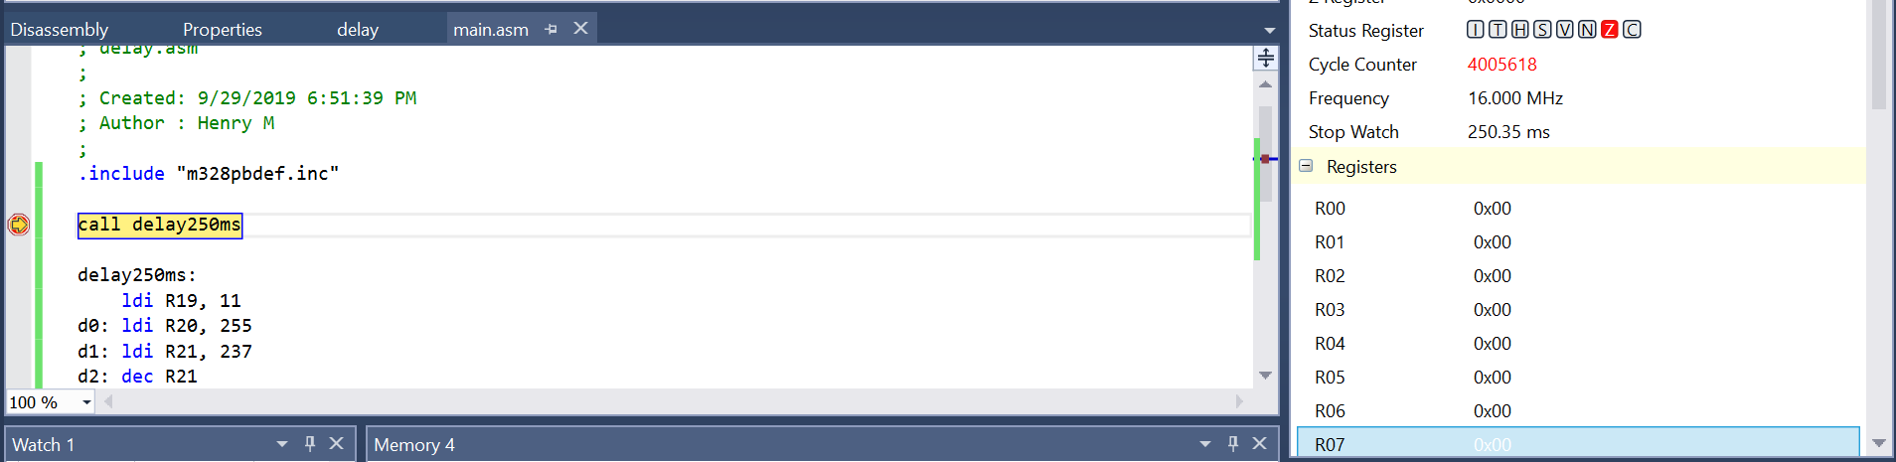

Time delay 375ms

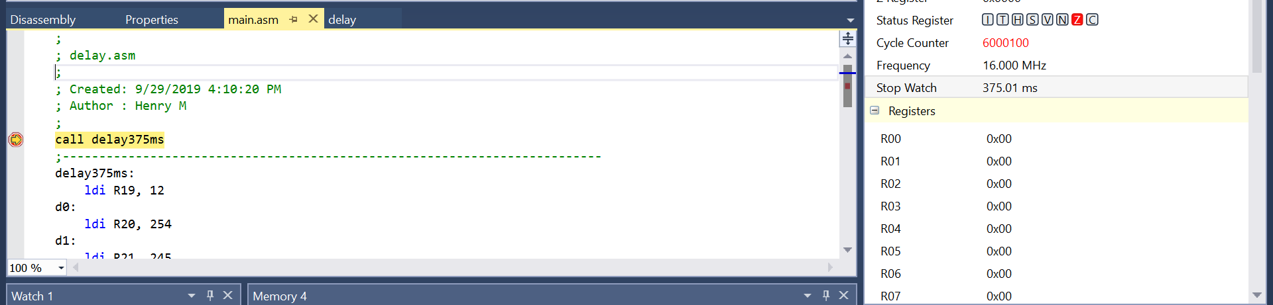

Program Compiled

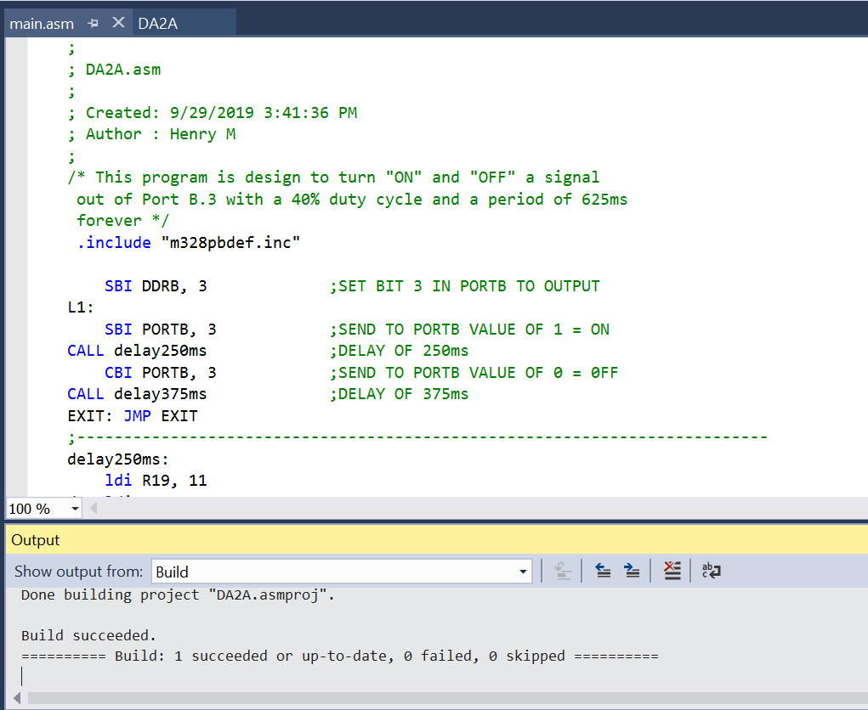

**Part2**

Time delay 1.333ms

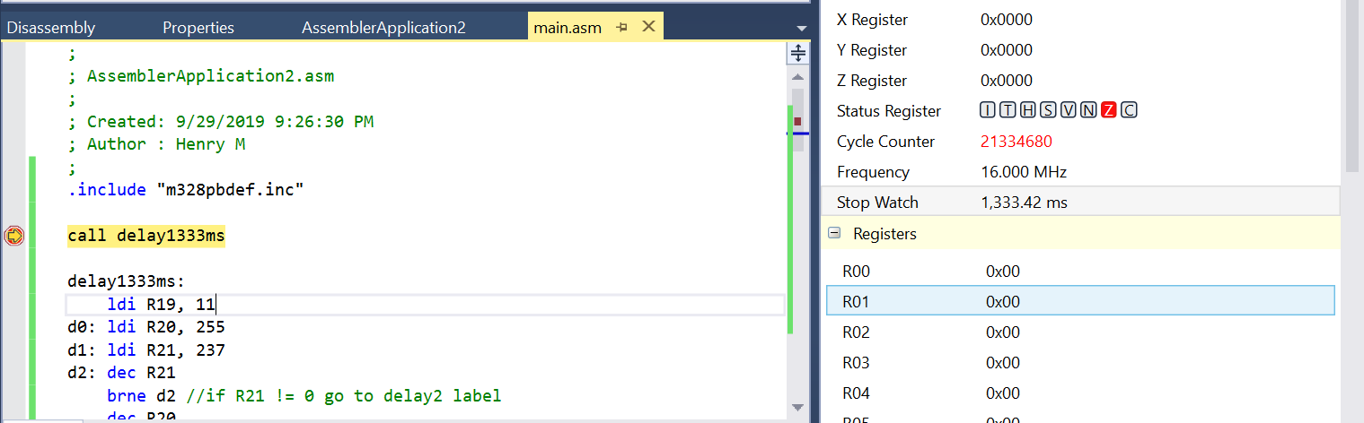

Program Compiled

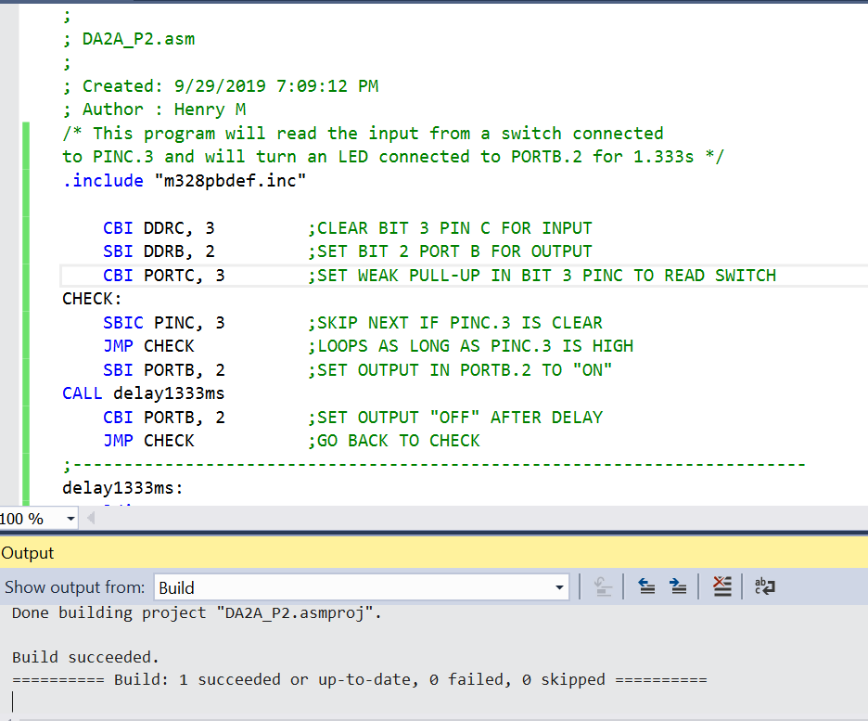

1. **SCREENSHOT OF EACH DEMO (BOARD SETUP)**

**Part 1**

**Part 2**

1. **VIDEO LINKS OF EACH DEMO**

**Part 1**

<https://youtu.be/ZlRS5mdJXZc>

**Part 2**

<https://youtu.be/QPk4nsopMxU>

1. **GITHUB LINK OF THIS DA**

**Part 1**

<https://github.com/mesah1/submissions/blob/master/DA2A/PART_1>

**Part 2**

<https://github.com/mesah1/submissions/tree/master/DA2A/PART_2>

**Student Academic Misconduct Policy**

<http://studentconduct.unlv.edu/misconduct/policy.html>

“This assignment submission is my own, original work”.

HENRY MESA